**What are NCDs?**

“Non-communicable disease (NCD)” or “Chronic Disease” refers to health problems that cause ongoing damage to the body. If these conditions are not prevented or treated, they will worsen and cause many problems.

The “big four” diseases are cardiovascular (heart and circulation), diabetes (too much sugar in the blood), cancer and chronic respiratory (lung) disease.

Leaders in the government and communities should work together to create healthier communities and countries. Efforts should be focused on lessening **major risk factors,** which include:

|  |  |
| --- | --- |
| **Tobacco** | * *Causes major lung problems, cancer, heart and circulation problems* * *Worsens diabetes* |
| **Harmful Alcohol Use** | * *Causes problems with the liver* * *Worsens high blood pressure and heart disease* * *Can lead to obesity* * *May lead to job loss if there is a drinking problem* |
| **Unhealthy Diet** | * *Leads to obesity, which causes heart disease, diabetes and joint problems.* * *Increases the risk of developing cancer* |
| **Physical Inactivity** | * *Leads to obesity and joint problems* |

**What you should know**

Tobacco is the only product sold in the USAPI that when used as instructed kills people. It is the only legal way to kill someone. Smoking harms nearly every organ of the body. It is a major risk factor for all major NCDs, including heart disease, diabetes, cancer and lung disease.

Effective tobacco policy can help to reduce the prevalence of these diseases. All jurisdictions have some form of tobacco policy, ranging from taxation to bans on tobacco sales to minors. However, the policies are not strong enough, are inconsistently enforced, and have many loopholes. To change this state of affairs will require considerable leadership and community engagement.

**Why is this important?**[1]

* Tobacco kills up to half of its users.
* Tobacco kills nearly 6 million people each year. More than 5 million of those deaths are the result of direct tobacco use while more than 600,000 deaths are the result of non-smokers being exposed to second-hand smoke.
* It is estimated that two people die each minute from tobacco–related disease in the Western Pacific Region.
* Nearly 80% of the world’s one billion smokers live in low- and middle-income countries.
* Consumption of tobacco products is increasing globally.

**Why is it important to have policies establishing and sustaining tobacco cessation programs?**

Successful tobacco cessation programs are effective in helping people quit smoking.

* Most smokers that are aware of the health dangers of smoking do want to quit. Counseling and medication can more than double their chance of succeeding.[2]
* There are many health benefits to quitting smoking.
  + Just after 20 minutes a smoker’s heart rate and blood pressure drop![3]
  + One year after quitting smoking the excess risk of coronary heart disease is half that of a continuing smoker’s.[4]
* Studies report 30-35% cessation rates at one year for intensive treatments and 10-29% for less intensive treatments.[5]
* Treatment for tobacco product addiction ranks high in cost-effectiveness among health program spending options.[6]

**Important messages to share with others**

* There are over 7,000 known chemicals found in secondhand smoke and 250 are known to be harmful.[7]
* Currently, there are only 21 countries (about 15% of the world’s population) that provide appropriate tobacco cessation support.[8] More tobacco cessation programs are needed worldwide!
* Evidence shows that the frequency of betel nut chewing is increasing in the Western Pacific Region and its use is more frequently associated with the chewing of tobacco. Even though betel nut has cultural significance, it needs to be clearly defined as only used in traditional matters, not used to encourage tobacco use. Betel nut is a carcinogenic that induces oral, esophagus, and stomach cancer.[9]
* Adaptation of existing cessation programs that are tailored to be culturally relevant to the Pacific Islands can help with system-level tobacco efforts.[10]

**An example of a successful policy**

According to the WHO, increase taxes on and prices of tobacco products, which are by far the “best buys” in tobacco control, are highly effective approaches to reducing tobacco consumption.[11]

**World Health Organization (WHO) Framework Convention on Tobacco Control (FCTC)**

🖰 <http://whqlibdoc.who.int/publications/2003/9241591013.pdf>

The Framework Convention on Tobacco Control by the World Health Organization identifies key policy interventions critical to combat tobacco. While not all jurisdictions are signatories to the Framework Convention, the content is relevant to all settings. To stop the NCD epidemic, leaders at all levels must commit to fully enacting the provisions outlined in the Framework Convention.

Article 14 is regarding the demand reduction measures concerning tobacco dependence and cessation:

1. Each Party shall develop and disseminate appropriate, comprehensive and integrated guidelines based on scientific evidence and best practices, taking into account national circumstances and priorities, and shall take effective measures to promote cessation of tobacco use and adequate treatment for tobacco dependence.
2. Towards this end, each Party shall endeavour to:

(a) design and implement effective programmes aimed at promoting the cessation of tobacco use, in such locations as educational institutions, health care facilities, workplaces and sporting environments;

(b) include diagnosis and treatment of tobacco dependence and counselling services on cessation of tobacco use in national health and education programmes, plans and strategies, with the participation of health workers, community workers and social workers as appropriate;

(c) establish in health care facilities and rehabilitation centres programmes for diagnosing, counselling, preventing and treating tobacco dependence; and

(d) collaborate with other Parties to facilitate accessibility and affordability for treatment of tobacco dependence including pharmaceutical products pursuant to Article 22. Such products and their constituents may include medicines, products used to administer medicines and diagnostics when appropriate.

To learn more about the guidelines for implementation for Article 14

* read the **WHO FCTC 2013 Edition**: 🖰<http://apps.who.int/iris/bitstream/10665/80510/1/9789241505185_eng.pdf>

*Who can I contact for more information?*

James Rarick

Technical Officer, Tobacco Free Initiative

WHO Western Pacific Regional Office

Manila, Philippines   
E-mail: 🖅 [rarickj@wpro.who.int](mailto:rarickj@wpro.who.int)

**Other successful policies**

Key Steps to Implementing Cessation Programs and Policies[12]

**Step 1**

Conduct Community Assessment

Look to see if actions need to be done to still develop support, gather resources, and conduct appropriate research

**Step 2**

Locate Available Resources

Use results of the communicate assessment to determine available resources and resources that are still needed

**Step 3**

Identify Cessation Strategies

Consider pros and cons of different ways to approach cessation along with results from community assessments to determine what approaches might work best

For lasting impact, consider policy strategies that will affect large groups of people

**Step 4**

Adopt strategies for cultural appropriateness

Use results of community assessments and expertise of community leaders to reflect upon which aspects of selected strategies need to be uniquely designed to be successful

**Step 5**

Conduct Program or Policy Campaign

Put your plan into actions to create the necessary policy and laws to achieve cessation programs

**Step 6**

Evaluate Efforts

Set up ways to determine whether or not cessation program and policy is meeting its original goals

1. **Tobacco Cessation Among Asian American and Pacific Islanders: A Community Approach** by Asian Pacific Partners for Empowerment, Advocacy, and Leadership (APPEAL). Published in 2006.

<http://www.appealforcommunities.org/media/docs/2336_CessationKit05Final.pdf>

*Summary:*

*Pages 8-9:* Figure 1 provides processes of change and activities that can be introduced at different stages of community readiness for cessation

*Pages 12-13:* Figure 3 provides different cessation approaches, and lists their pros and cons

*Pages 16-17:* list of steps for implementing cessation programs

*Pages 18-20:* provides an example of policy change in the Samoan community through working with churches.



1. **Building Tobacco Cessation Capacity in the U.S. - Affiliated Pacific Islands** by A.M. David et al. Published by Health Promotion Practice. Published in 2013

<http://hpp.sagepub.com/content/14/5_suppl/88S.full.pdf+html>

*Summary:* A group in Guam pilot tested a cessation training intervention in four Pacific Islands – the Republic of Palau, Federated States of Micronesia, the Commonwealth of the Northern Mariana Islands, and the Republic of the Marshall Islands. They adopted the Brief Tobacco Cessation Intervention model from the University of Arizona and tailored it to be more culturally appropriate for the Pacific Island regions. The participants in the study completed the cessation intervention training and rated their knowledge before and after the training. These ratings showed a statistically significant increase in confidence across all competency areas for delivering brief advice. This study showed the importance of culturally competent adaptation of cessation training.

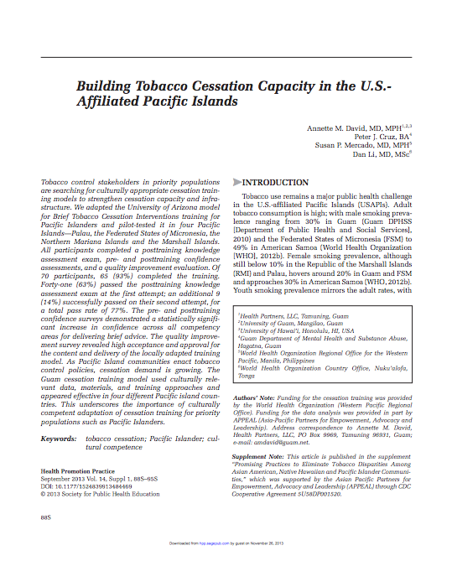

1. **The Review of Areca (Betel) Nut and Tobacco Use in the Pacific – A Technical Report by the WHO, Western Pacific Region**. Published in 2012.

<http://www.wpro.who.int/tobacco/documents/betelnut.pdf>

*Summary:* Betel nut and tobacco chewing has become a significant health problem in the Western Pacific Region. The review provides recommendations in addressing the betel nut chewing problem, the prevalence of it in certain countries within the western pacific region, and background information and history of the betel nut.

*Pages 11-17:* Discusses measures, including education and advocacy, need to be taken to discourage the use of betel nut with or without tobacco.

*Page 15:* discusses tobacco dependent treatments.

The document also provides data of betel nut use in the:

* + *Page 23:* Commonwealth of the Northern Mariana Islands
  + *Page 23-24:* Federated States of Micronesia
  + *Page 24:* Guam
  + *Page 25:* Republic of Palau
  + *Page 25-26:* Republic of the Marshall Islands

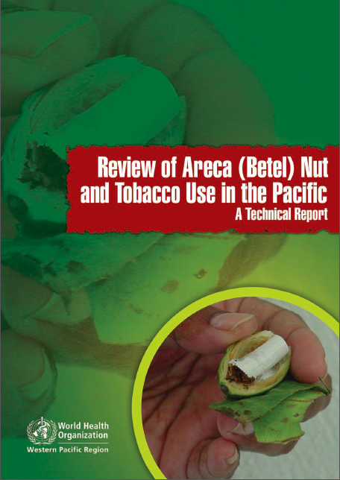

**Who can I contact for more information?**

James Rarick

Technical Officer, Tobacco Free Initiative

WHO Western Pacific Regional Office

Manila, Philippines  
E-mail: 🖅 [rarickj@wpro.who.int](mailto:rarickj@wpro.who.int)

1. World Health Organization Tobacco Factsheet, July 2013, http://www.who.int/mediacentre/factsheets/fs339/en/
2. http://www.who.int/fctc/guidelines/adopted/article_13/en/
3. Mahmud A., Freely J. (2003). Effect of smoking on arterial stiffness and pulse pressure amplification. *Hypertension, 41*(1), 183.
4. US Department of Health and Human Services. (2010). *US Surgeon General’s Report*, p. 359. Retrieved from http://www.surgeongeneral.gov/library/reports/tobaccosmoke/full_report.pdf.
5. Institute of Medicine. State programs can reduce tobacco use. Washington DC: National Academy Press. 2000.
6. Hamilton JL. The demand for cigarettes: advertising, the health scare, and the cigarette advertising ban. Rev Econ Stat 1972;54:401-11.
7. U.S. Department of Health and Human Services. The Health Consequences of Involuntary Exposure to Tobacco Smoke: A Report of the Surgeon General. Atlanta: U.S. Department of Health and Human Services, Centers for Disease Control and Prevention, Coordinating Center for Health Promotion, National Center for Chronic Disease Prevention and Health Promotion, Office on Smoking and Health, 2006.
8. WHO report on the global tobacco epidemic, 2013, http://apps.who.int/iris/bitstream/10665/85380/1/9789241505871_eng.pdf
9. The Review of Areca (Betel) Nut and Tobacco Use in the Pacific – A Technical Report by the WHO, Western Pacific Region focuses on the reduction of smokeless tobacco use. 2012. http://www.wpro.who.int/tobacco/documents/betelnut.pdf
10. Annette D. M. et al. (2013). Building Tobacco Cessation Capacity in the U.S. - Affiliated Pacific Islands. *Health Promotion Practice*. http://hpp.sagepub.com/content/14/5_suppl/88S.full.pdf+html
11. World Health Organization. (2011). Global Health Report on noncommunicable diseases 2010. Geneva, Switzerland. http://www.who.int/nmh/publications/ncd_report_full_en.pdf
12. Tobacco Cessation Among Asian American and Pacific Islanders: A Community Approach*.* Asian Pacific Partners for Empowerment, Advocacy, and Leadership (APPEAL). 2012*.* <http://www.appealforcommunities.org/media/docs/2336_CessationKit05Final.pdf>